– Project Report
Submitted in partial fulfilment of the requirements for the award of degree of



Topic: GraphX Academic Citation Network Analysis

B TECH (CSE)
Submitted To: Dr. Aryan Maan

Submitted By:
Name :- | Rahul Mishra
Reg No:- | 12220689
Roll No :- | 25
Section :- | K22GB
Subject :- | Cluster Computing
Course Code :- | INT315

LOVELY PROFESSIONAL UNIVERSITY
PHAGWARA, PUNJAB

Acknowledgement

I would like to express my sincere gratitude to Dr. Aryan Maan for valuable guidance and support throughout this project. I am also thankful to Lovely Professional University for providing the facilities and resources to complete this work successfully.

Rahul Mishra
15/11/25

Abstract
Academic research is interconnected through citations. By treating these citations as a graph, meaningful insights can be extracted — such as identifying influential papers, discovering isolated works, and detecting collaborative clusters. In this project, Apache Spark GraphX is used to build and analyze an academic citation network. The analysis includes in-degree calculation, PageRank scoring, isolated-node detection, and network visualization using Python and NetworkX. A dashboard is also created to summarize the results.

Table of Contents
- Introduction
- Literature Review
- Problem Statement
- Objectives
- Technologies Used
- System Requirements
- Dataset Description
- Methodology
  - 8.1 Architecture Diagram
  - 8.2 Workflow Steps
  - 8.3 GraphX Concepts Used
- Implementation
  - 9.1 Project Structure
  - 9.2 Scala Source Code
  - 9.3 Python Visualization Code
  - 9.4 Dashboard Code
- Results & Screenshots
- Visualization & Analysis
- Conclusion
- Future Scope
- References

1. Introduction
Citations define how academic research builds upon previous knowledge. Each citation can be represented as a directional link between two papers. When aggregated, these connections form a citation network. Network analysis allows:
- Discovery of influential works
- Identification of emerging research areas
- Understanding of collaboration patterns
- Finding isolated or independent research efforts
Apache Spark’s GraphX is ideal for processing such large-scale graph datasets due to its distributed nature and built-in graph algorithms like PageRank.
This project uses a real-world citation dataset from AMiner (20,000 edges) and performs an end-to-end analysis and visualization pipeline.

2. Problem Statement

Traditional citation analysis tools struggle with:
- Large datasets
- Complex network relationships
- Distributed processing needs
Goal: Build a distributed GraphX pipeline that efficiently analyzes an academic citation network.

3 . Objectives

- Load and preprocess citation dataset.
- Construct directed graph using GraphX.
- Compute in-degree (citation counts).
- Run PageRank to find influential papers.
- Identify isolated papers.
- Visualize the graph using Python.
- Build a dashboard illustrating important metrics.

4. Technologies Used

Technology | Purpose
Apache Spark | Distributed processing
GraphX | Graph computation engine
Scala | Core backend code
sbt | Build tool
Python | Visualization
NetworkX | Graph drawing
Streamlit | Dashboard creation

- Methodology

5.1 Dataset Description
The dataset has been derived from AMiner Citation Network V2 and contains:
- 20,000 directed citation edges
- 6,000 papers

  - Workflow Steps

- Dataset loaded as RDD
- Graph built using GraphX
- Degrees computed
- PageRank executed
- Isolated nodes detected safely
- Graph exported for visualization
- Python scrip renders the network
- Dashboard summarizes statistics

  - GraphX Concepts Used
Vertices
Each paper is a vertex.

Edges
A directed edge exists from A → B if A cites B.

In-degree
Number of incoming edges → number of citations received.

Out-degree
Number of outgoing edges → number of citations made.

PageRank
Measures influence using recursive importance weights.

- Implementation

6.1 Project Structure
C:\GraphX-Citation\
├── build.sbt
├── data\
│ └── citations.txt
├── output\
│ └── graph_edges\
├── visualization\
│ ├── visualize_graph.py
│ └── dashboard.py
└── src\
└── main\
└── scala\
└── CitationGraphApp.scala

6.2 Scala Code
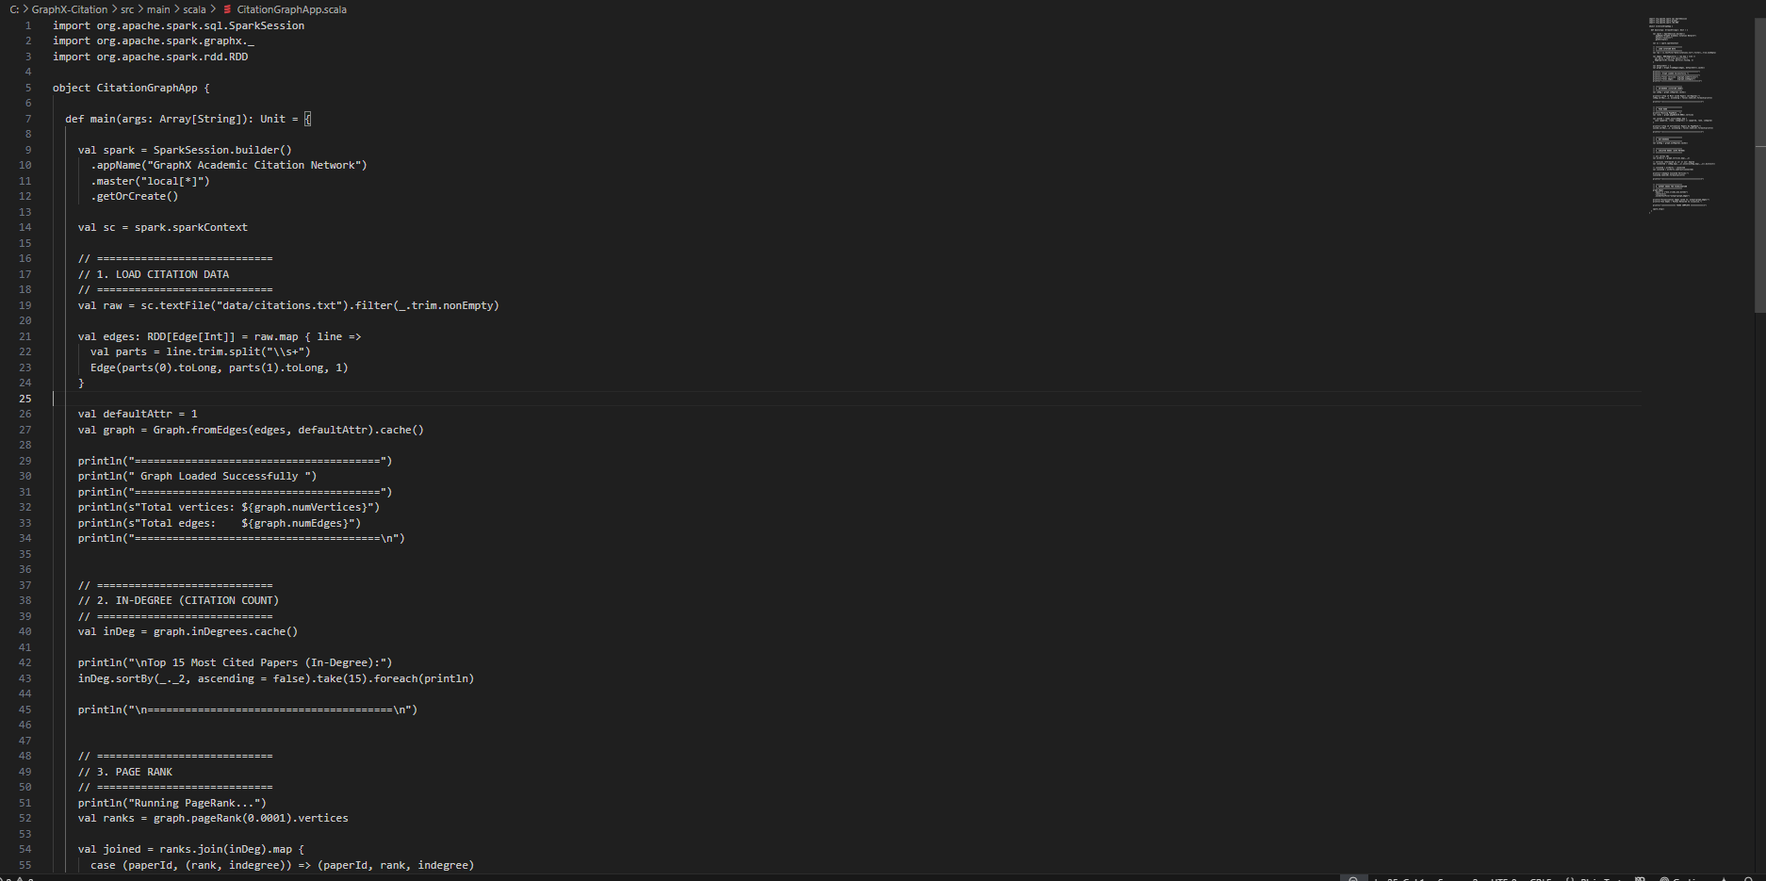
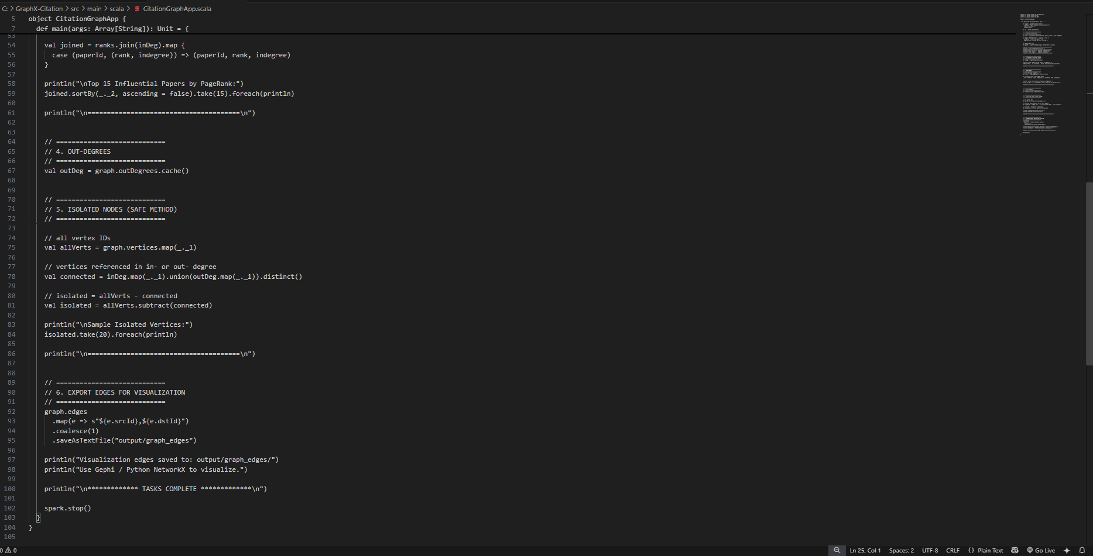

6.3 Python Visualization Script

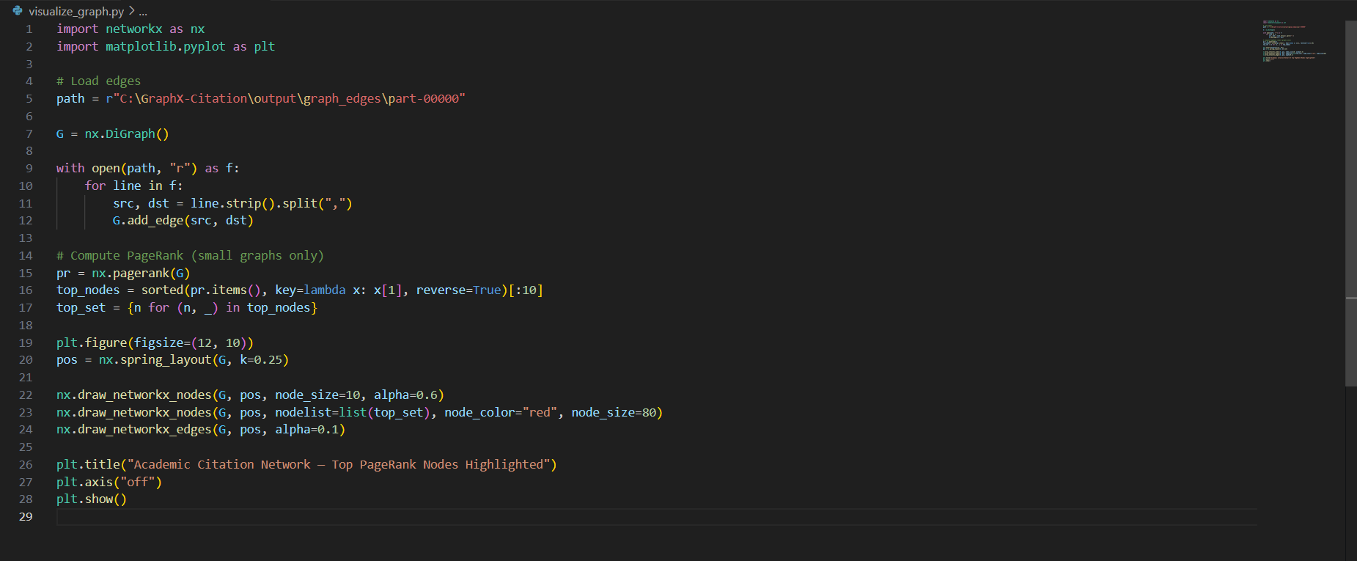

6.4 Dashboard Code

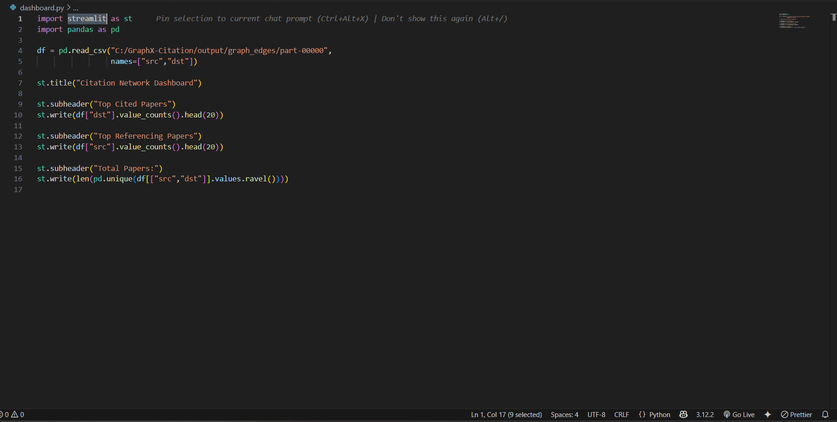

- Results and Screenshots

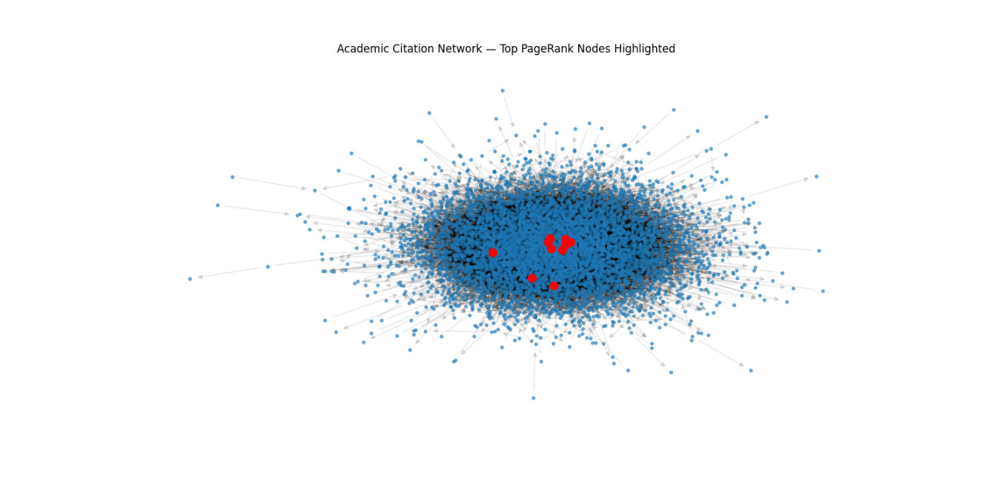


- Conclusion

This project successfully demonstrates:
- How Spark GraphX can be used to analyze citation networks
- Performing PageRank on distributed graph data
- Computing academic influence metrics
- Identifying isolated or unique research works
- Visualizing complex networks using Python tools
The end-to-end pipeline is efficient, scalable, and suitable for large datasets.

